# Push Notifications with Parse

**PART 2: Receiving Parse Push Notifications on Android**

**Author: Muhammad Shahab Hameed**

## Sources

Project homepage on Github - <https://github.com/shahabhameed/parse_push_notifications>

Download Zip – <https://github.com/shahabhameed/parse_push_notifications/archive/master.zip>

## Overview

This is a three-part tutorial series that will demonstrate how to send Parse’s Push Notifications from the backend server to the client devices (Android & IPhone). In the first part, a REST based backend server was built with Java EE Spring4 and Jersey framework that utilizes Parse’s Rest API’s to send Push Notifications.

This is the second part of the series, and in this part we will build an Android client using Android Studio IDE targeting Android Honeycomb (API SDK Level 11) and Lollipop (API SDK Level 22) that will receive push notifications send by the backend server.

## Requirements

The following software have been used to implement this tutorial.

1. Java SDK 1.7+ (Version 8 update 65)
2. Android Studio (Version 1.4)

## Receiving Push Notifications on Android Client

Step 1 Creating A Blank Project

Parse provides a starter project built using the gradle dependency system to quickly jump start a project for push notifications. For that, head over to <https://parse.com/apps/quickstart>. You will be presented with the following screen. Click on the “Push” icon.

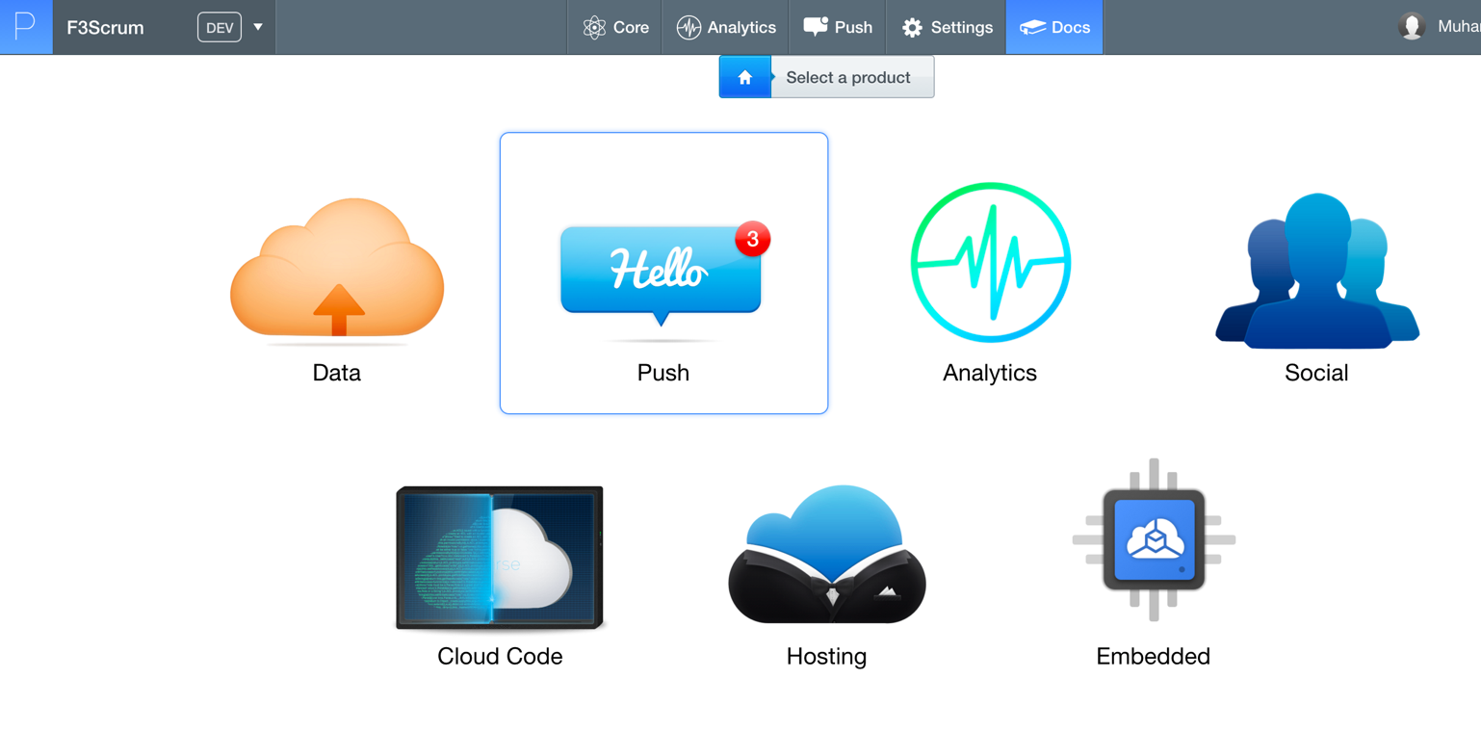

After that, you will be asked to provide an environment. Click on the “Android” icon.

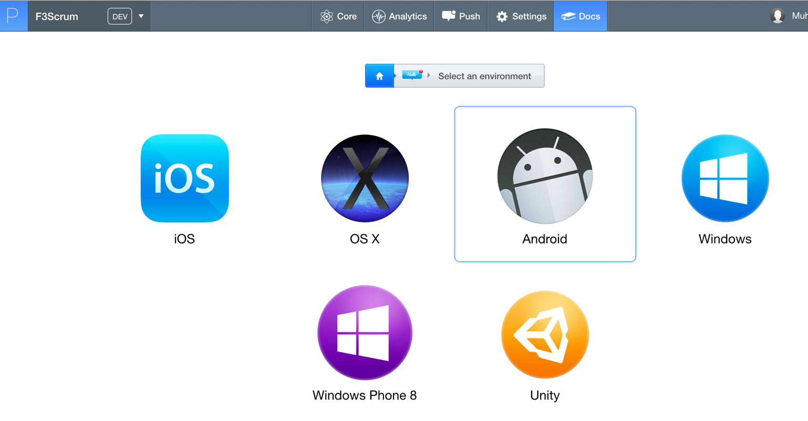

Then, on the next screen click “Native (Java)” project.

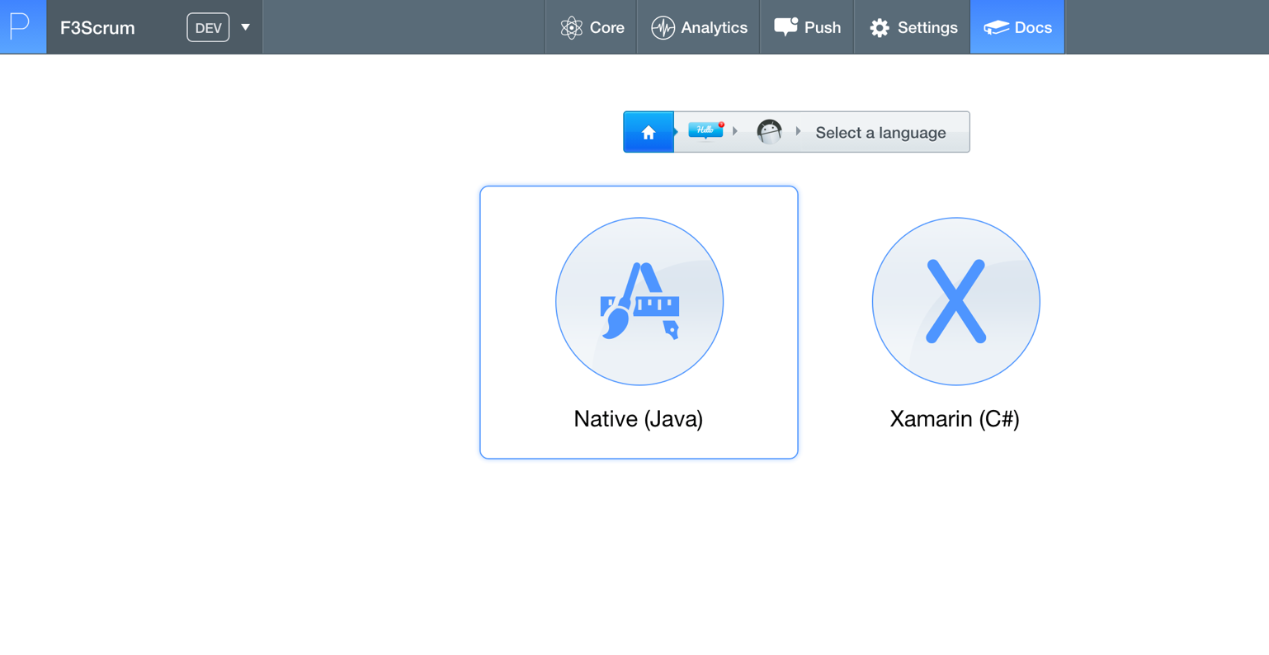

Then, click “New Project”.

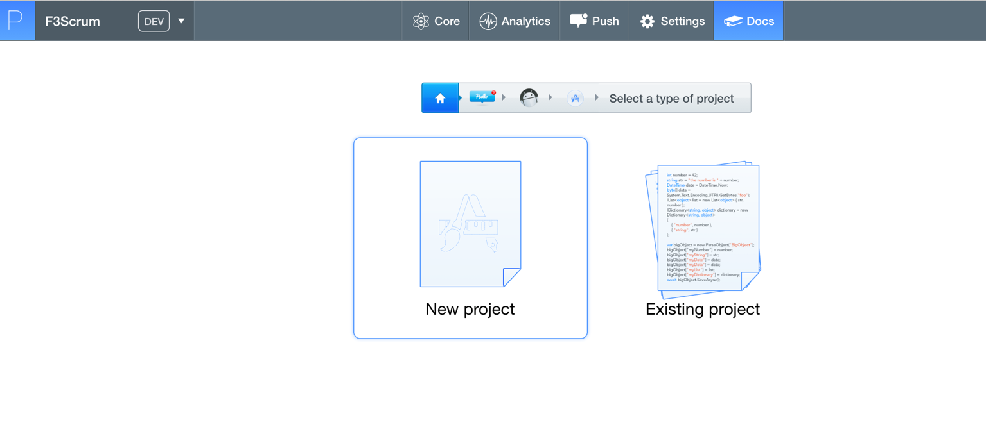

At this point, Parse starter project would be configured for you. We will just download it on our computer. Click on “Download the blank Android Project”

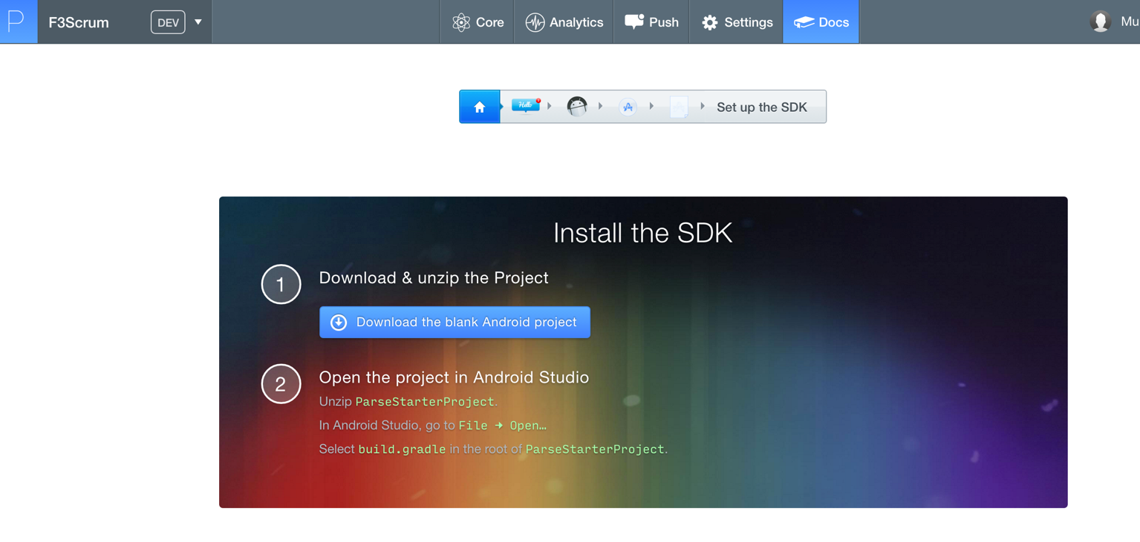

Step 2 Importing the Project in Android Studio

Next, we will extract this project”, and import in in Android Studio. Click on File -> New -> Import Project … I have extracted the zip file in **“F3-Parse-Android”** folder and imported in the Android Studio.

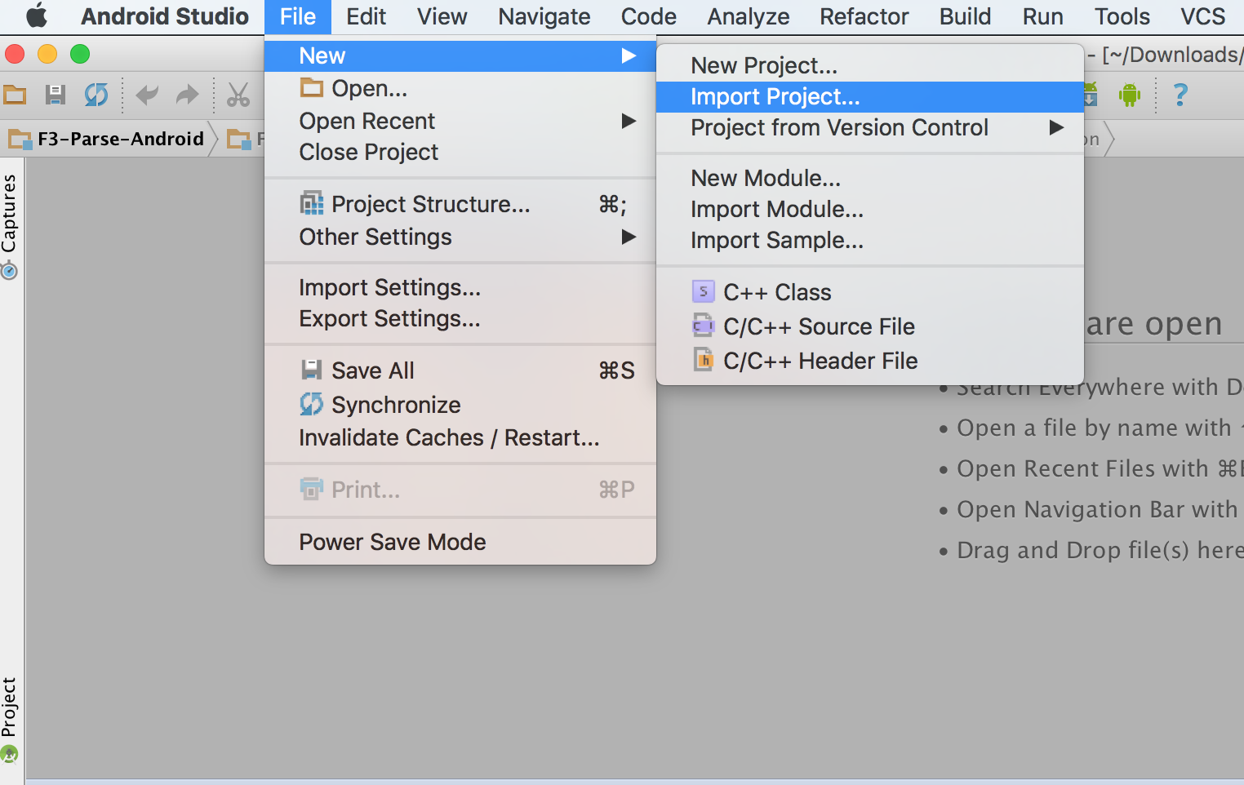

Then, select your extracted folder and import it. The gradle dependency system will download all the dependencies of the project. Once the dependencies have been downloaded, you can refactor the “ParseStarterProject” project. I have refactored it to “F3Scrum”. I have also refactored the package name from “com.parse.starter” to “com.folio3.parse”.

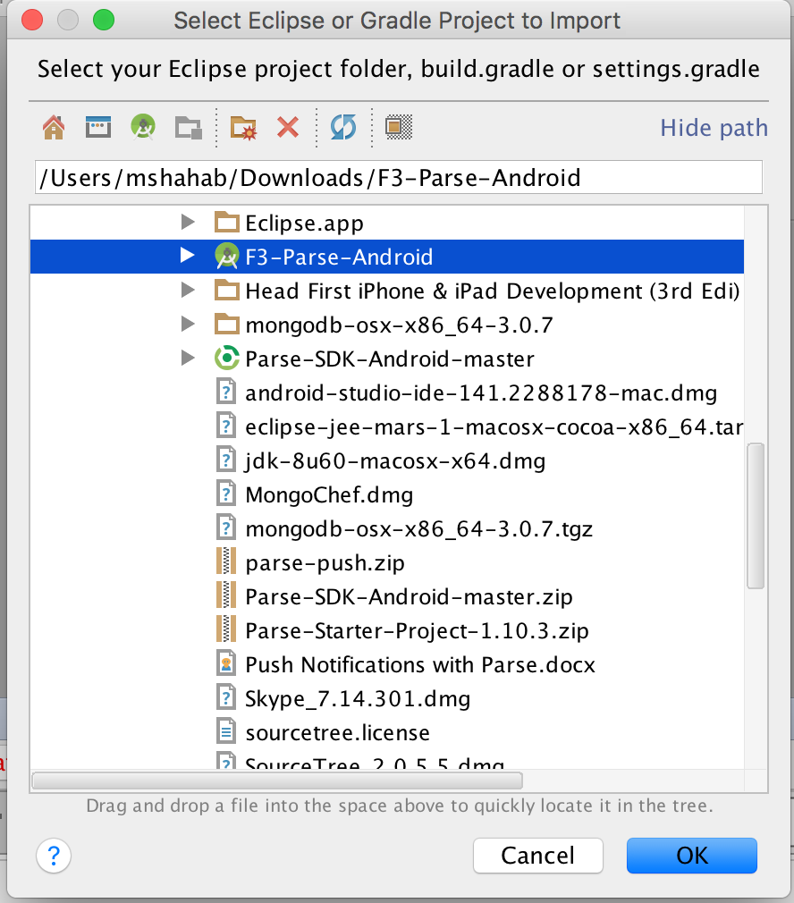

Next, Once the application is created go to “Settings” -> “Keys” and note down the following keys that will be used later as configuration in our backend server implementation.

1. Application ID
2. Client Key

well in Eclipse.

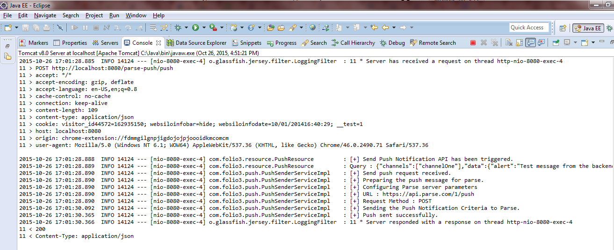

Step 10 Configuring the Gradle build file.

In this step we are going to configure the gradle dependency system to our requirements. I’ll change the minimum SDK version to 11, compile SDK version to 22 and buildToolsVersion to 22.0.1. As of 1st November 2015, Parse Library doesn’t support version 23 (Marshmallow) of Android SDK (<https://github.com/ParsePlatform/Parse-SDK-Android/issues/189)>.

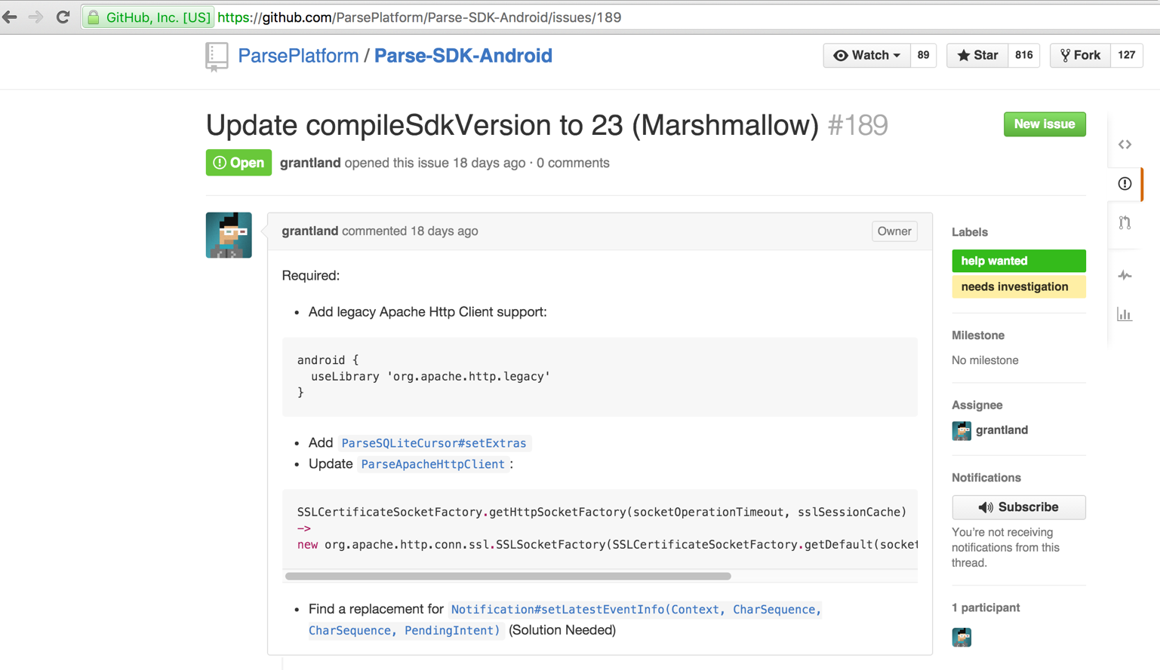

The main project build.gradle file would look like as follows.

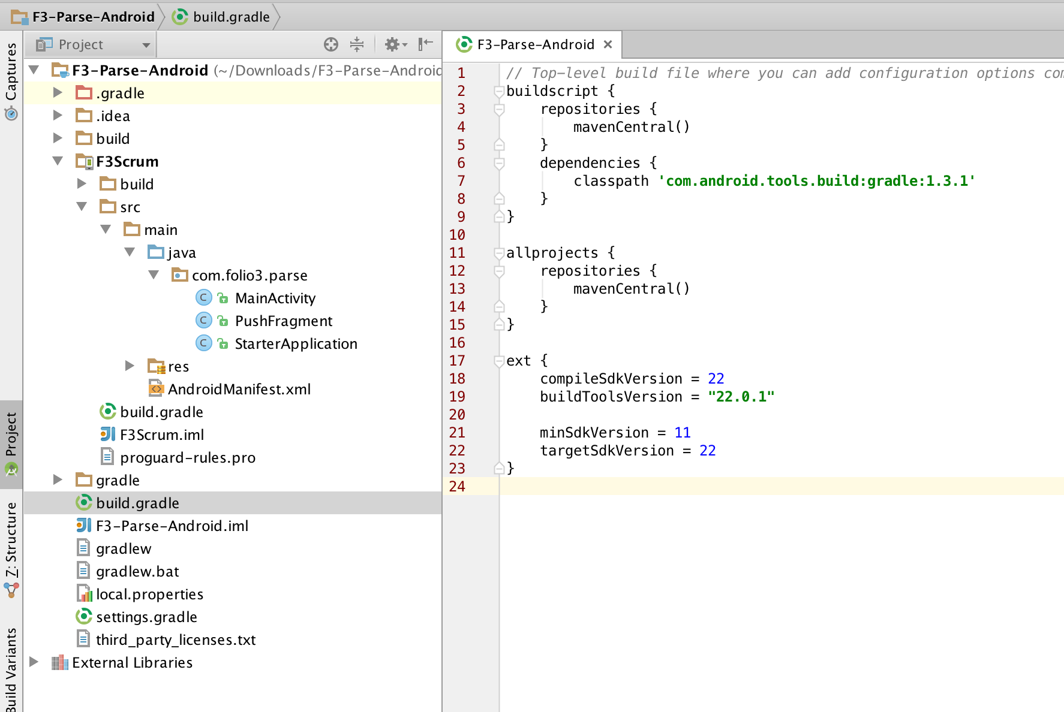

The build.gradle file of the module “F3Scrum” would be changed to reflect our refactored application package “com.folio3.parse”.

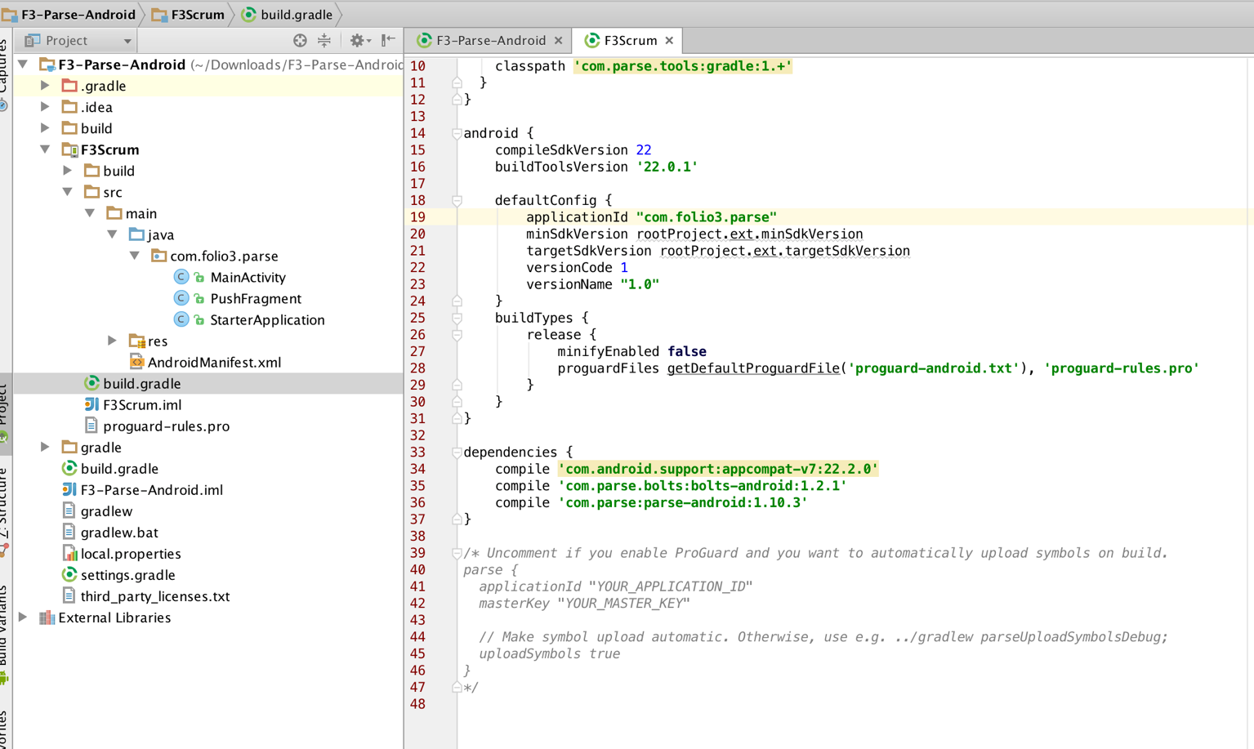

Summary

In this tutorial, we created implemented a backend server using Java Spring and Jersey framework that sends Push notifications to our clients. We configured and deployed our application on the Tomcat servlet container and tested our service using the Postman client. In the second and third parts, we will create an Android and IPhone application to receive push notifications.